Product Category | SIM Card Connector
Card Connection Method | Push-push Type
Card Type | NanoSIM card
Connector Type | Card Socket
Maximum Body Height | 1.25mm
Contact Material | Copper Alloy
Contact Plating | Gold Plated
Operating Temperature Range | -40℃~+85℃
Maximum Soldering Temperature | 260℃
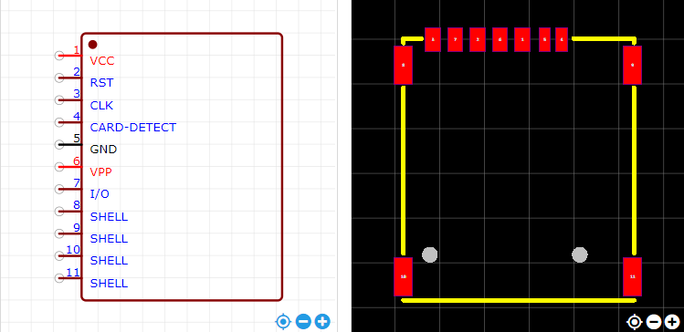
https://item.szlcsc.com/353303.html

